Question 2:

1. There are $mn-k$ tiles in a $(m,n,k)$-puzzle.
2. In a $(3, 3, 1)$-puzzle, there are 8 unique tiles so there are $8!$ ways to arrange them. There is 1 empty square so in a 3x3 grid it can be placed in 9 places. So there are $9×8!$ ways to arrange the tiles therefore 9! ways.  
   In a $(m,n,k)$-puzzle, there are $mn-k$ unique tiles so there are $\left(mn-k\right)!$ ways to arrange them. There is also $k$ empty squares. There are $\frac{mn!}{\left(mn-k\right)!k!}$ ways to put the empty tiles into the board. Therefore, there are a total number of $\left(mn-k\right)!\frac{mn!}{\left(mn-k\right)!k!}=\frac{mn!}{k!}$ ways to arrange a $(m,n,k)$-puzzle.
3. 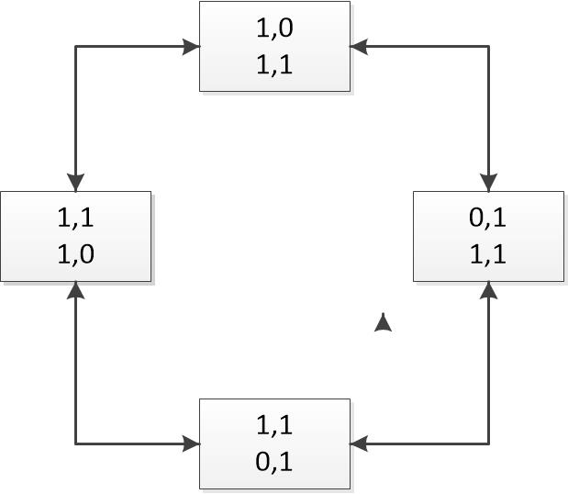In the graph below, 1 means the tile is filled, and 0 means the tile is empty. In the initial state, the empty tile in on the top right corner. We can move it to the top left or bottom right. The arrows are two-way because they can go back to the previous way. Both of these states can go to the state which the empty tile is on the bottom left. The arrows are also 2-way because it can go back to the previous state. So there are 4 states in the graph below. If each non-empty tile is unique, there are $4 ×3!=24$ different states.